3 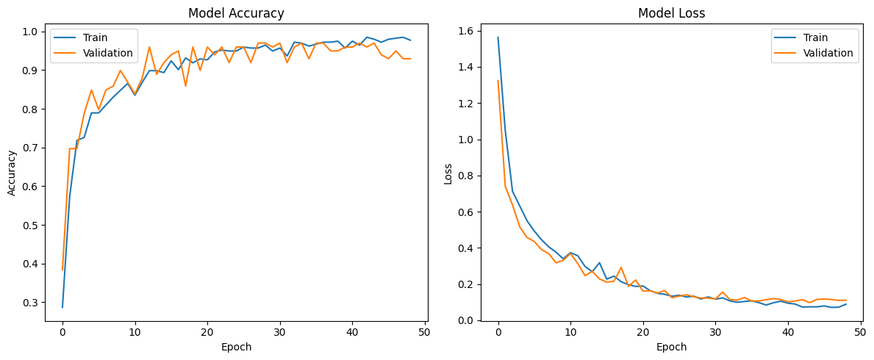Model 5 currently performs the best with 96-97% accuracy, Model 4 is also close

—------------------------------------------------------ MODEL 2—-----------------------------------------------------

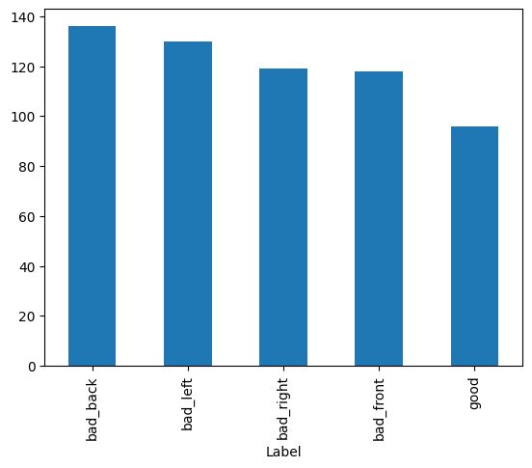
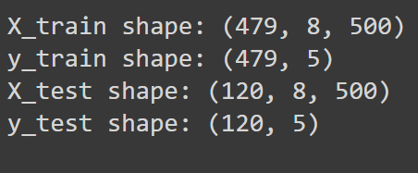

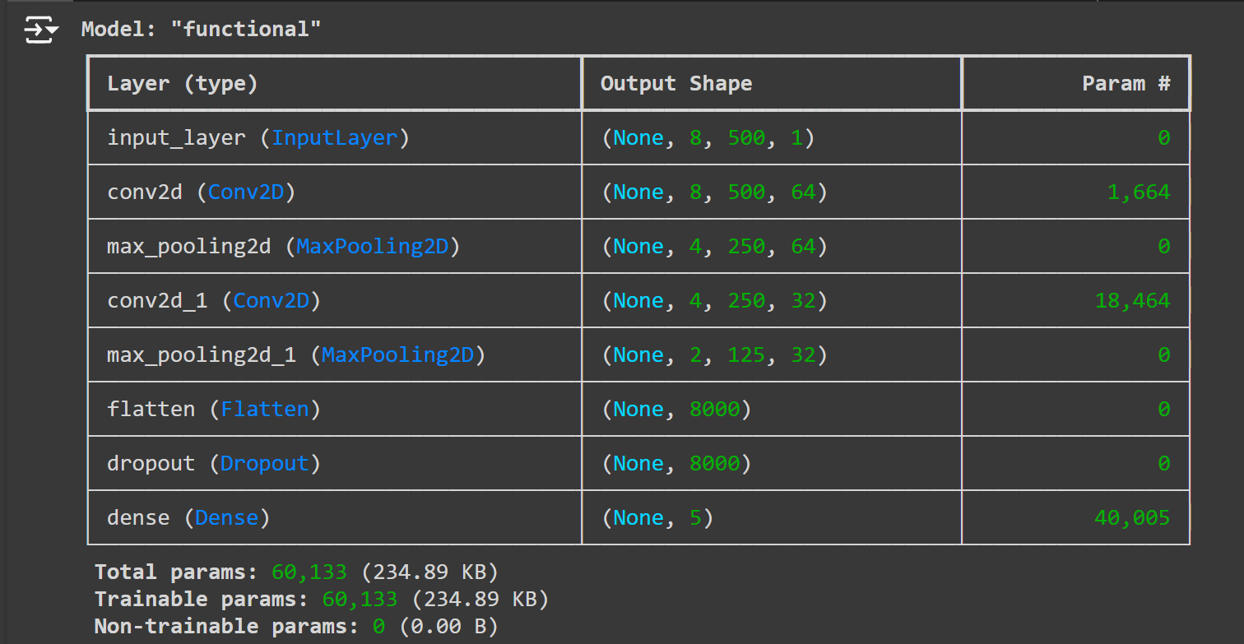
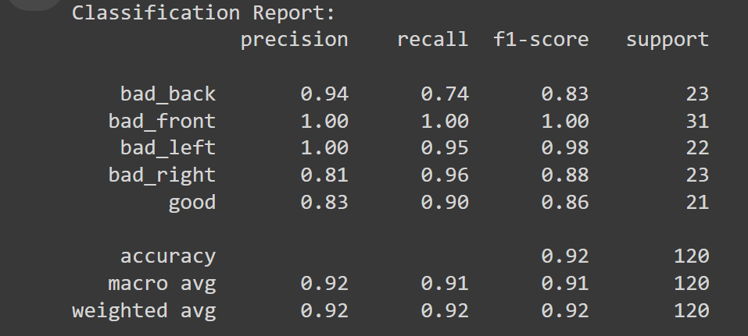
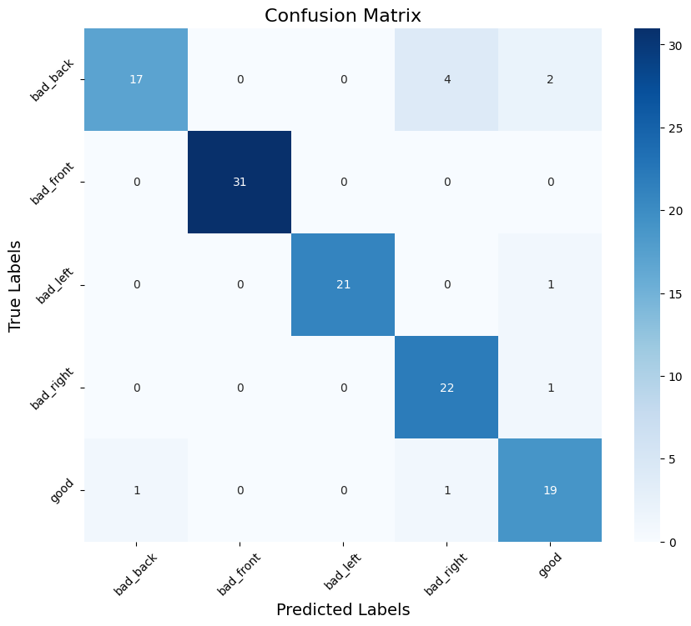

—------------------------------------------------------ MODEL 3—-----------------------------------------------------
*No change in training or testing data from model 2
* three CNN layers surprised that this was not to much of an improvement but is smaller than the previous the model
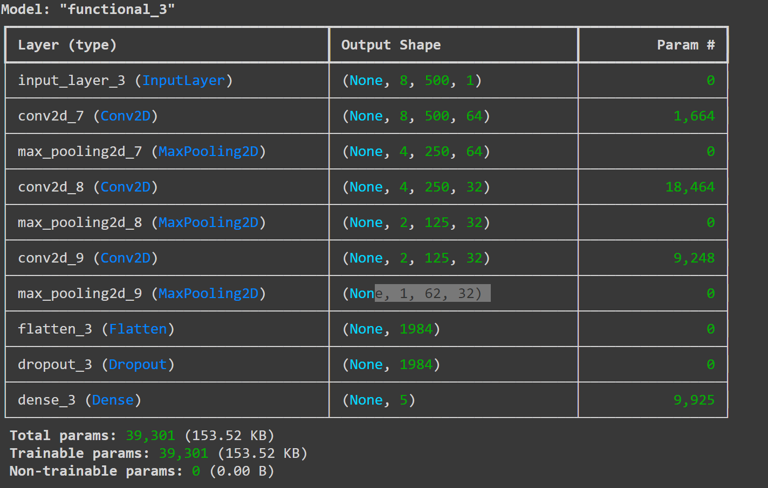
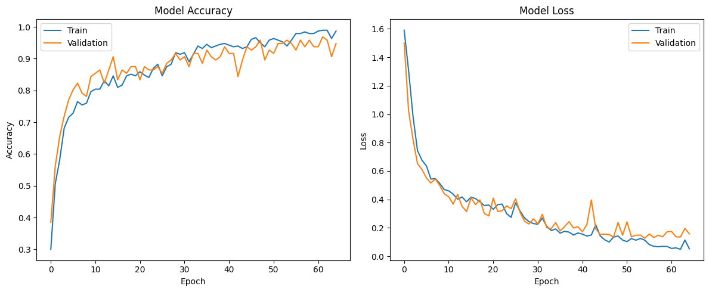
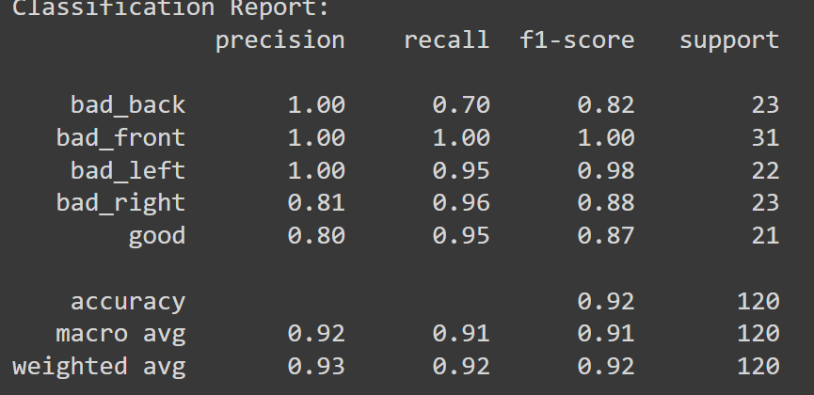
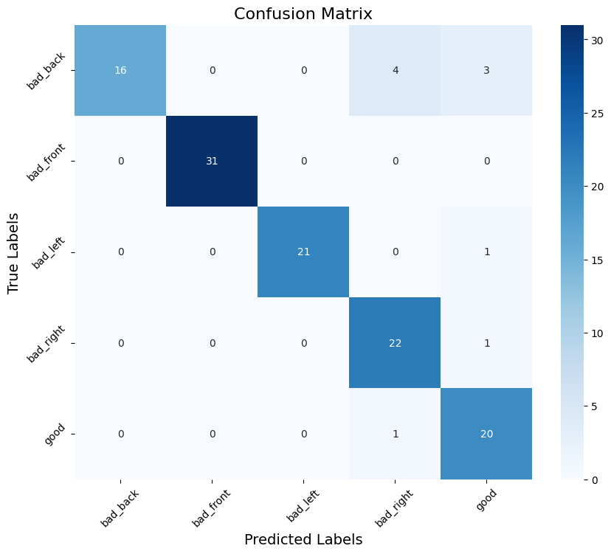

—------------------------------------------------------ MODEL 4—-----------------------------------------------------
*No change in training or testing data from model 2
* Bigger filter size was the main change, upgraded to a 7x7 improved performance
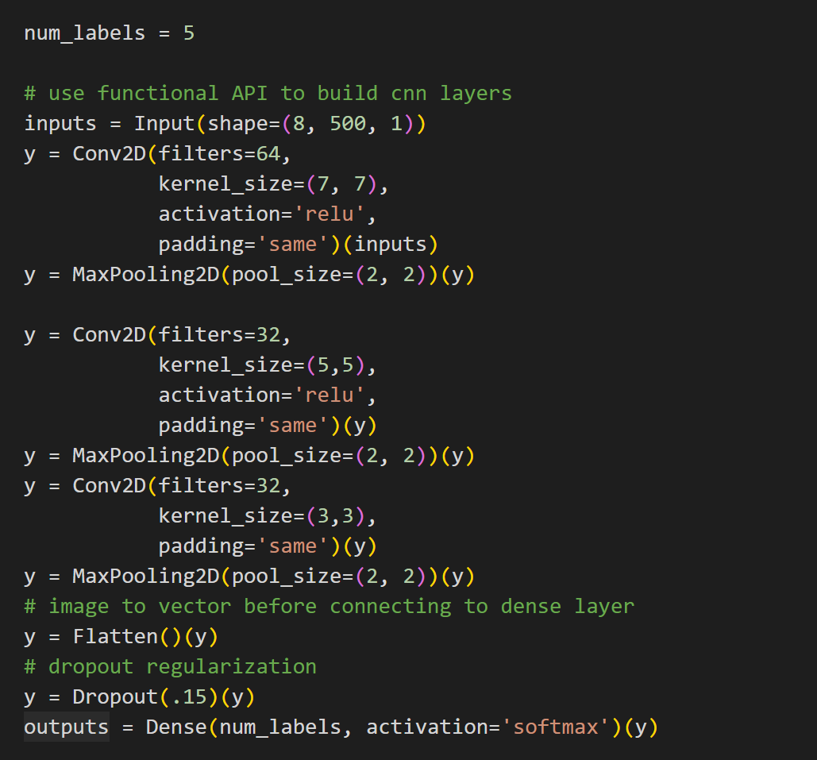
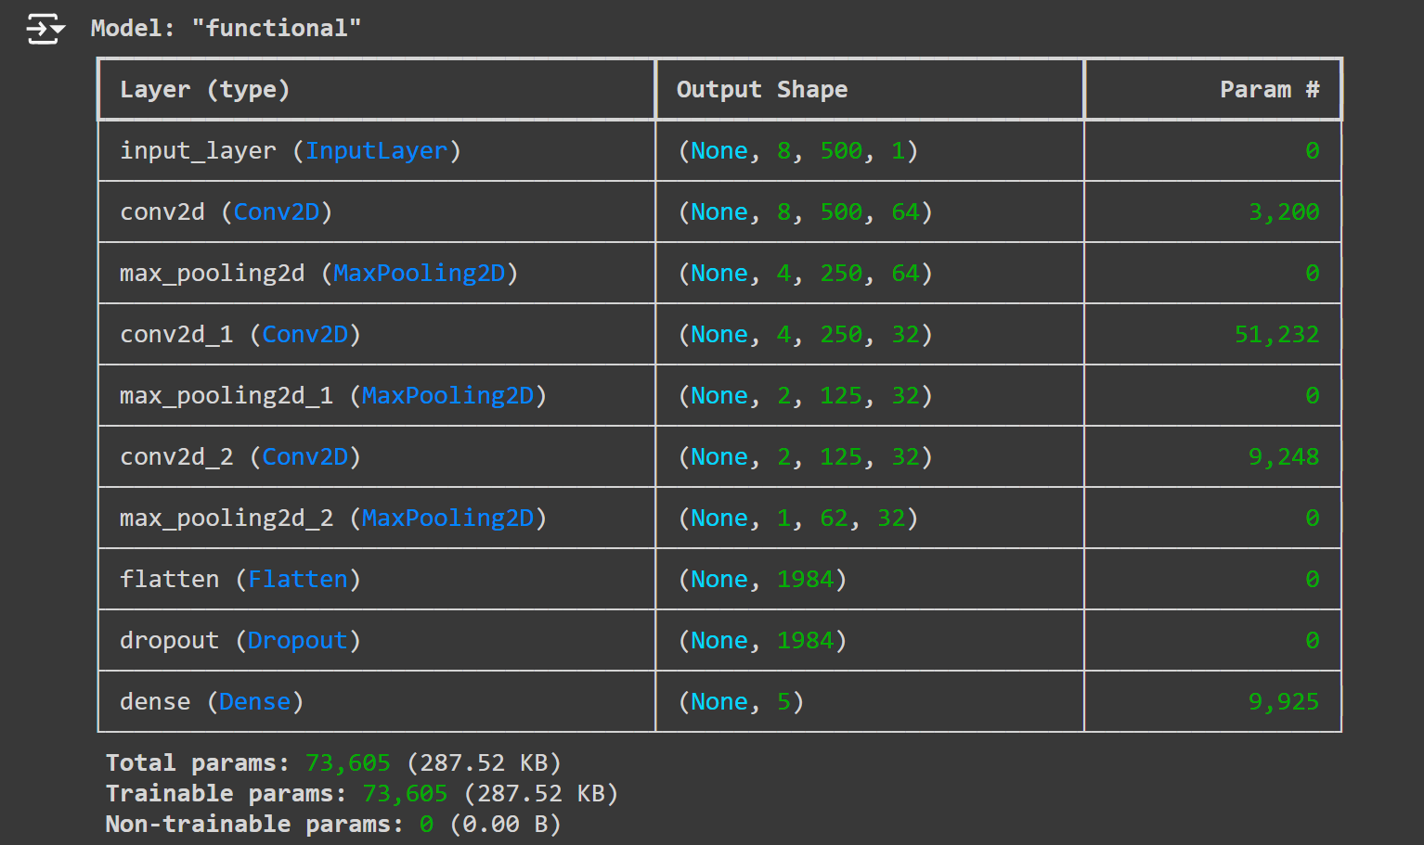
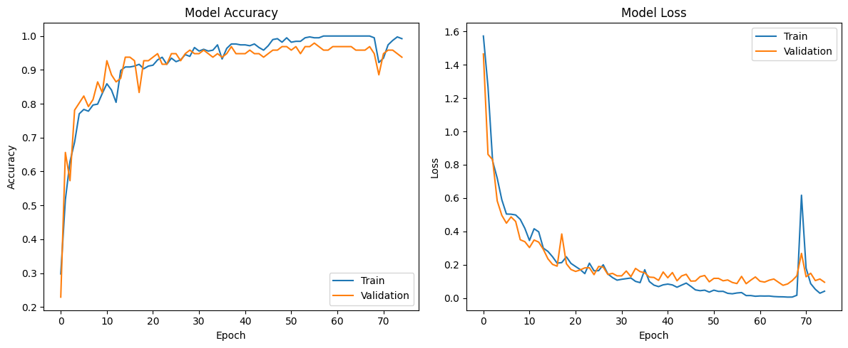
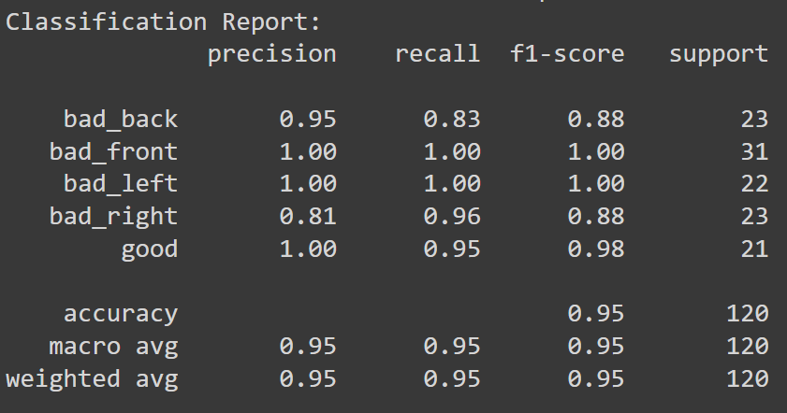
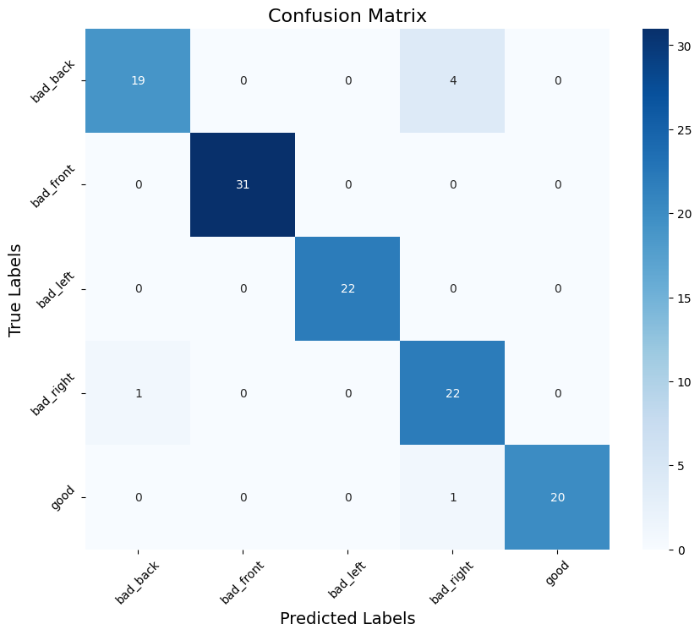

—------------------------------------------------------ MODEL 5—-----------------------------------------------------

*No change in input data from model 2
* using Dilated and strided layers appears to have increased the performance
* normalized to a value of 3.3 works the best?
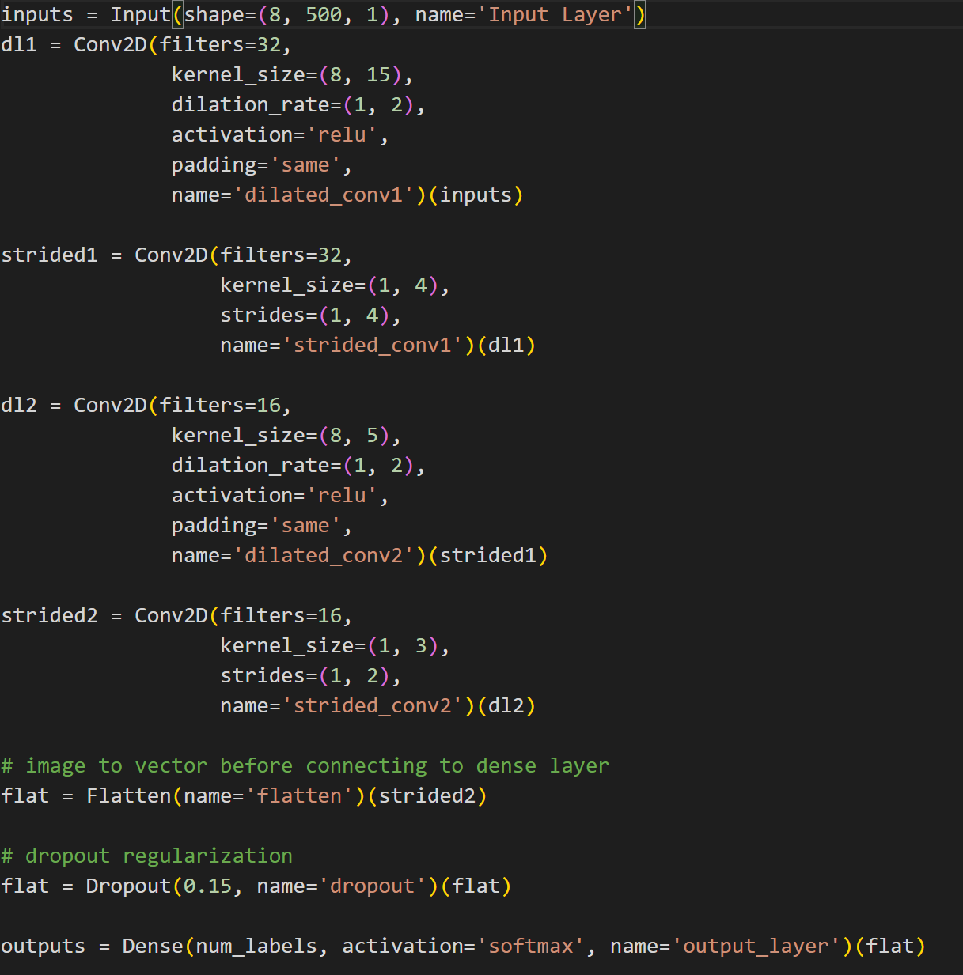
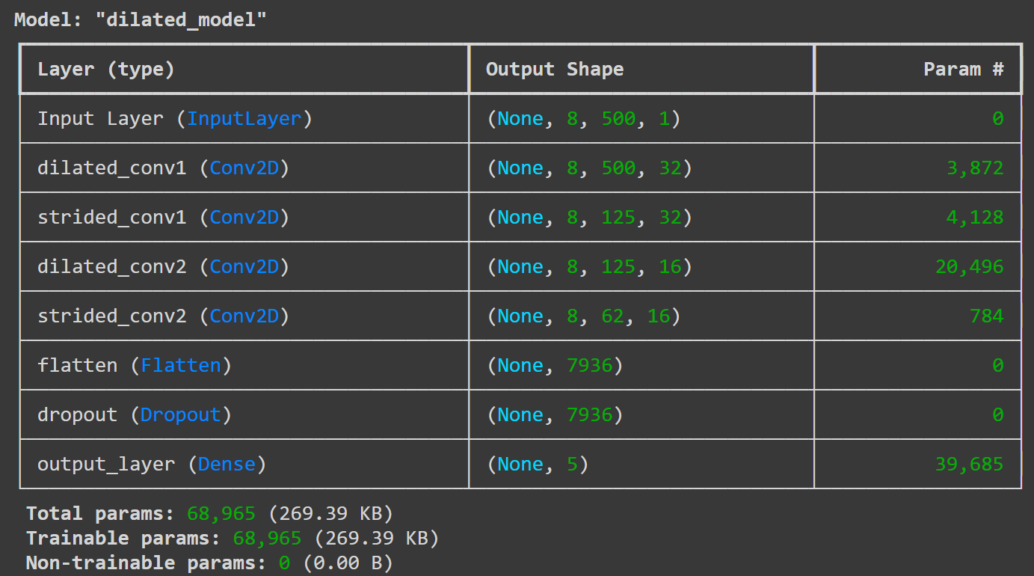
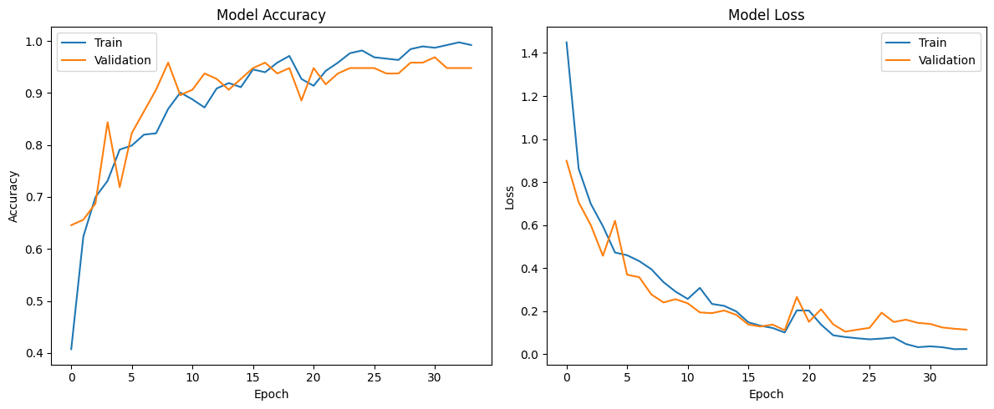
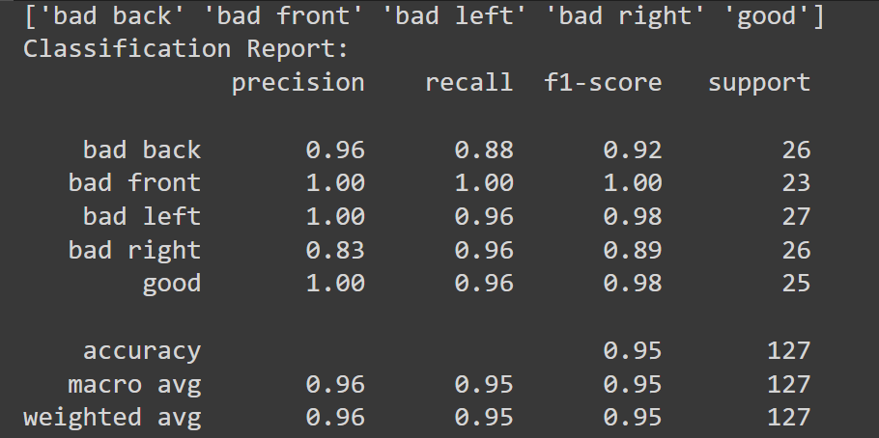
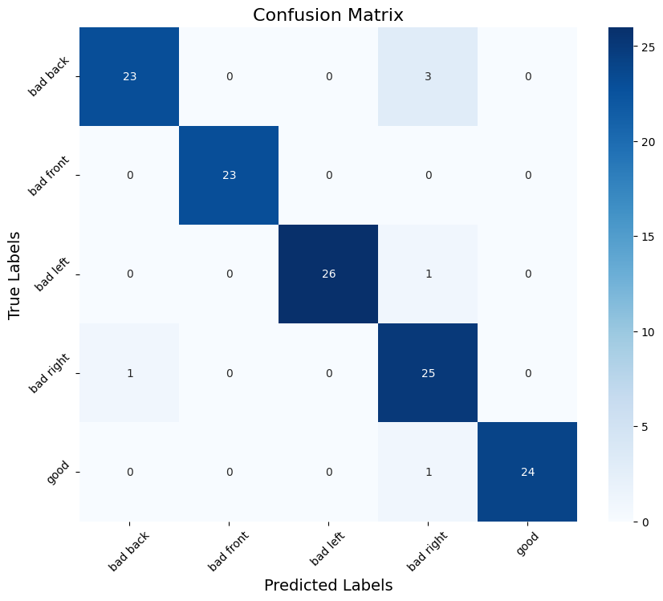
WIth learning rate decay:
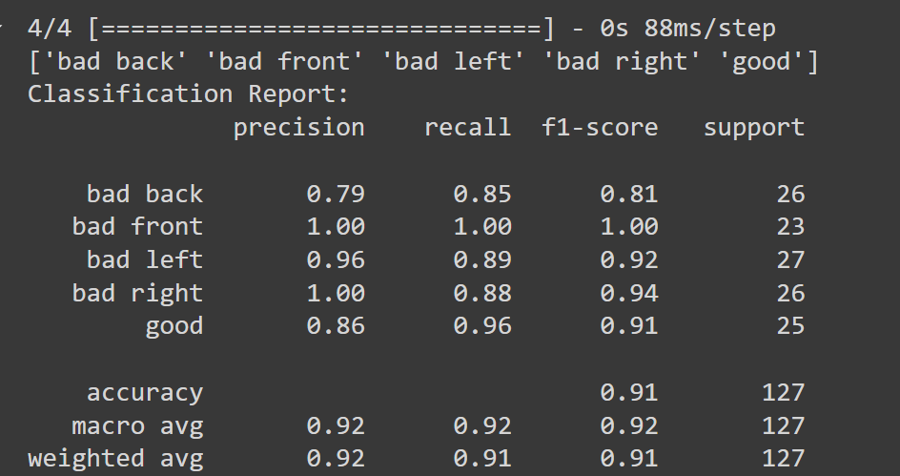
—------------------------------------------------------ MODEL 4.1 -----------------------------------------------------

*No change in input data from model 2
* Updated learning rate so that it decays over time to prevent overfitting
* 93% accuracy, performs the best on unseen data
* normalized to a value of 1.5 works the best?
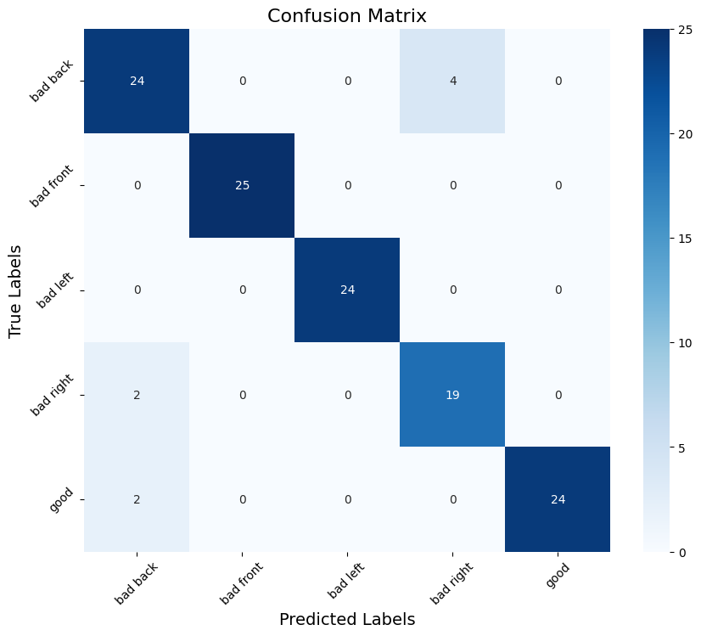
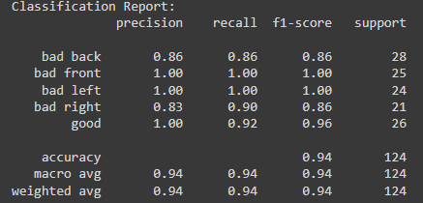
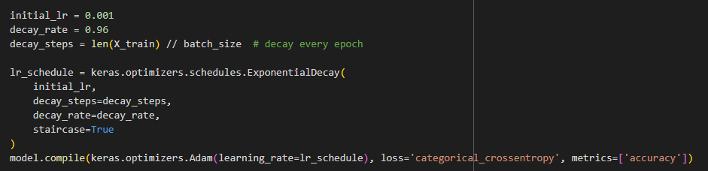

—------------------------------------------------------ MODEL 6—-----------------------------------------------------
- an improvement on model 5 sort of
- Uses SGD instead of Adam optimizer https://medium.com/geekculture/a-2021-guide-to-improving-cnns-optimizers-adam-vs-sgd-495848ac6008
- Less testing accuracy but better generalizability, in particular, performs exceptionally well with the large unseen ellipse, 96%. Still struggles with bad_back and bad_left for unseen rectangle 50%
- Had to downgrade to tensorflow 15 for model conversion from a high level keras functional object to a tflite. Essentially no drop in performance.
- 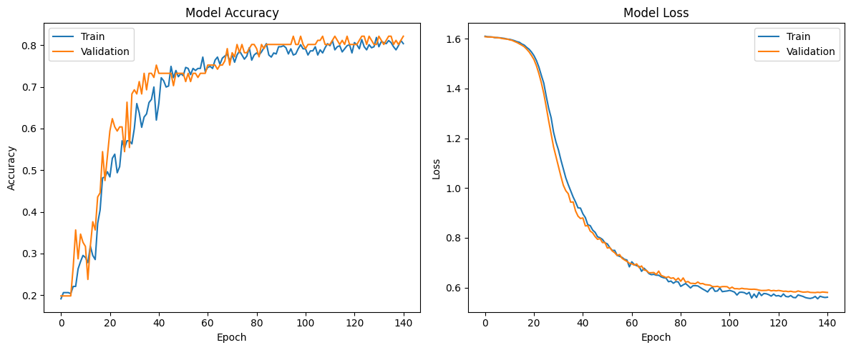
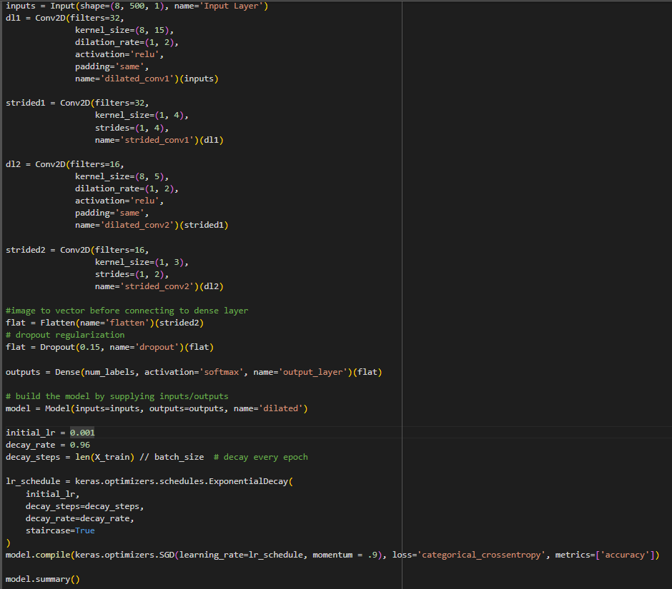
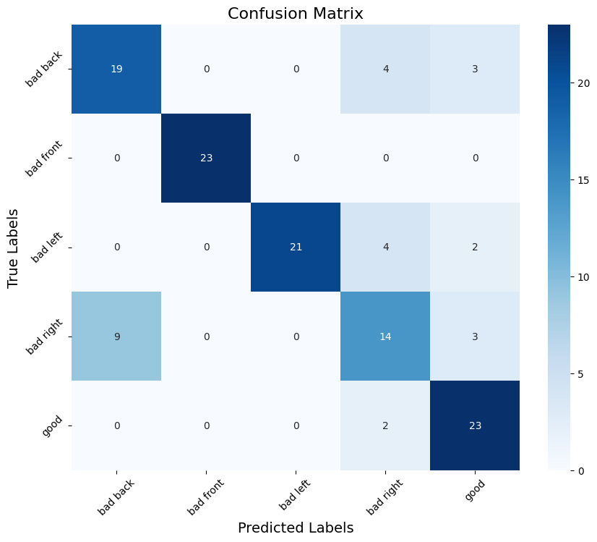
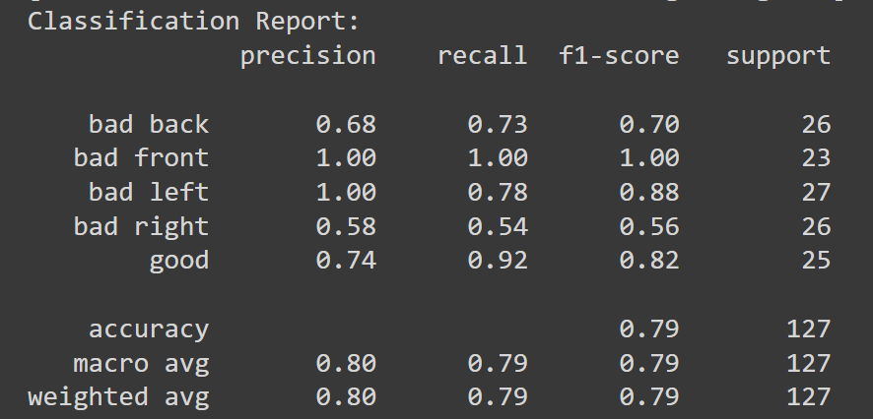

—------------------------------------------------------ MODEL 7—-----------------------------------------------------
An improvement on Model 4, uses the sgd algorithm instead of adam
Currently uses 2.2 data, need to look into 3.3 and 1.5 seems to not make as much of a difference on this. Architecture emphasizes focusing on sensors rather than time series.
Performs 100% on unseen medium circles and 73% on unseen large ellipses. Still quite poor at rectangles.
